WEEK 8-GIT-Hands On

- Git HOL

→To confirm that git is installed the following command is executed:
git --version
Output: git version 2.50.1.windows.1
→To configure the editor,executed the command :
git config --global core.editor notepad++ -multiInst -nosession
→created a new project “GitDemo” by executing the command :
git init.
Output:Initialized empty Git repository in C:/Users/samin/GitDemo/.git/
→created a file “welcome.txt” and added content to the file, executing
the command:
echo "Welcome to the GitDemo project" > welcome.txt.
→verified if the file “welcome.txt” is created by executing the command:
ls -al
→verified the content of the file by executing the command:
cat welcome.txt.
→Checked the status by executing the command:
git status.

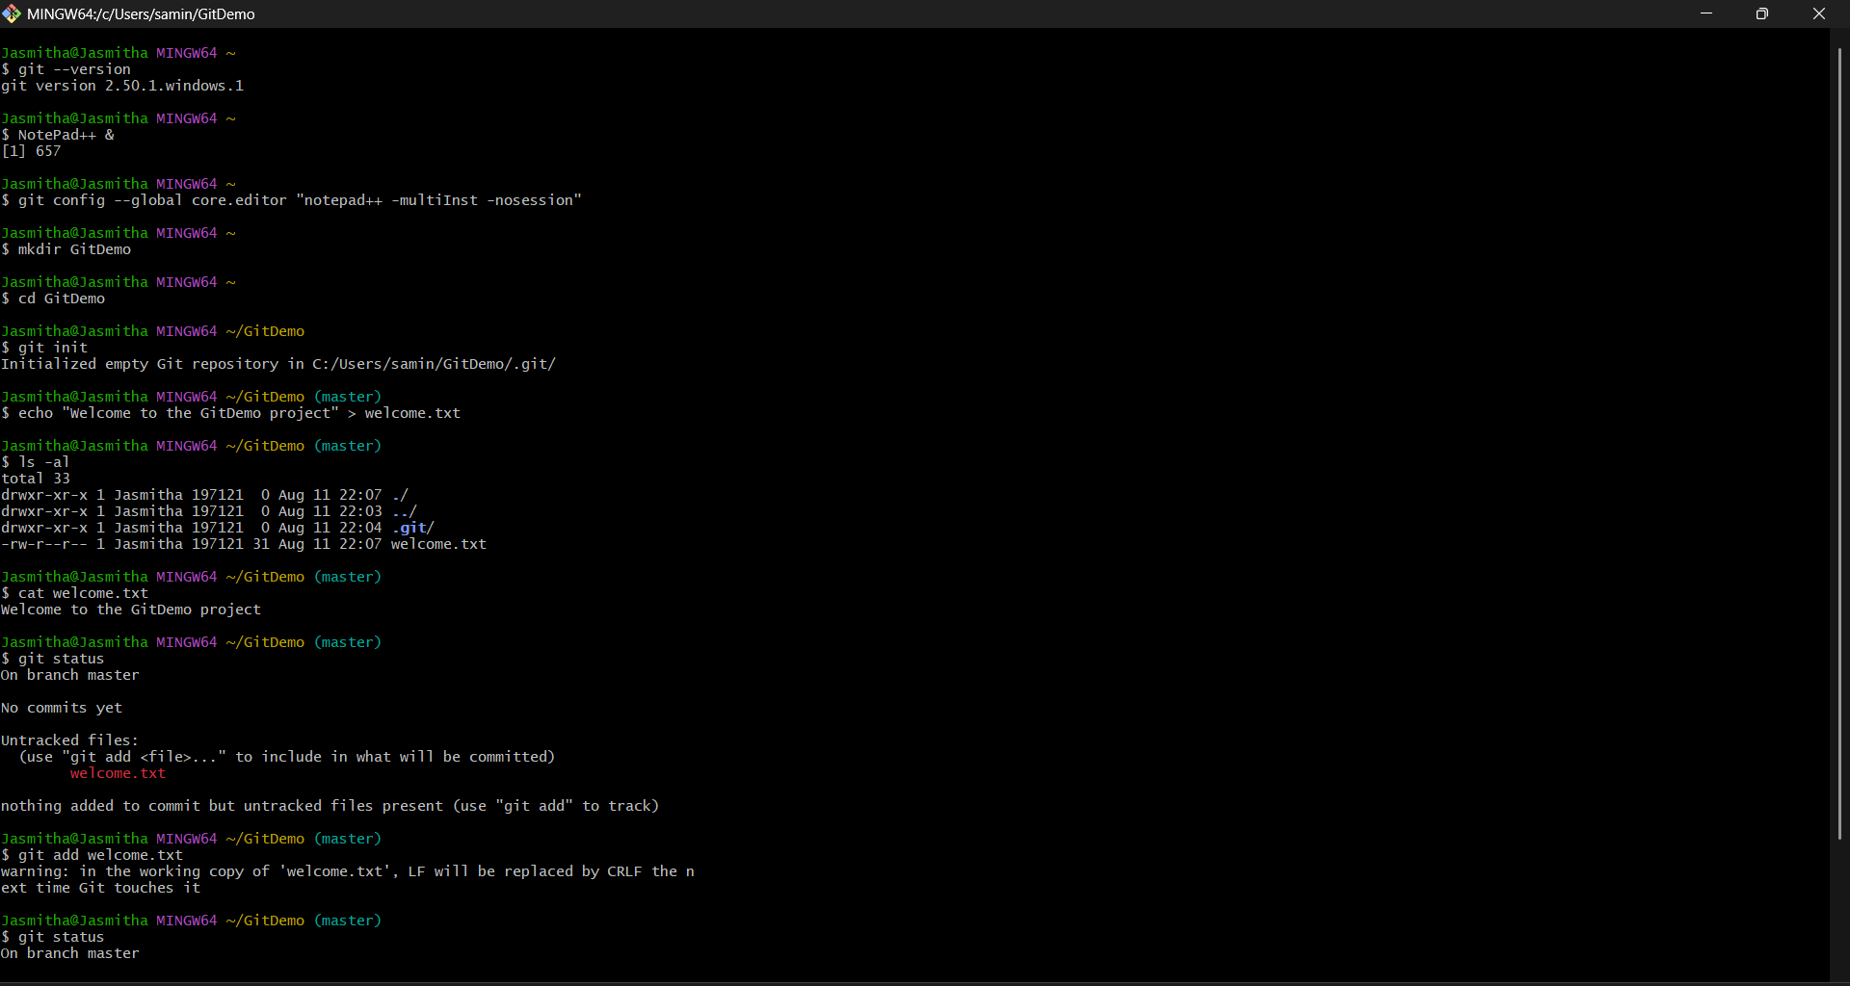

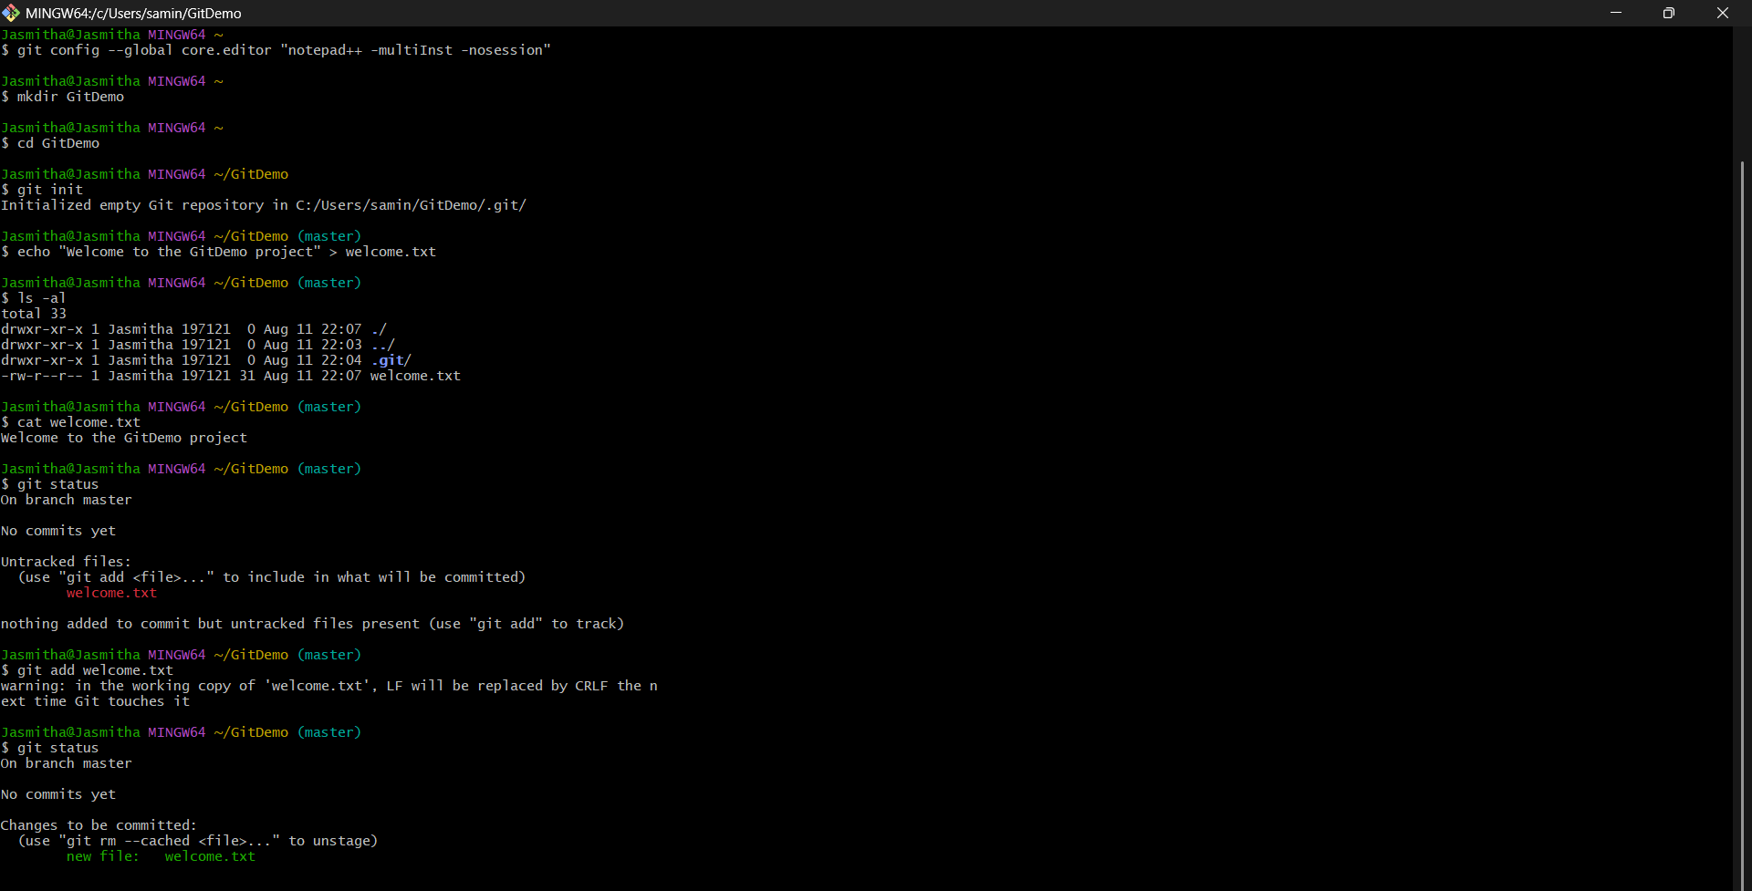

- Git HOL

Create a “.log” file and a log folder in the working directory of Git. Update the .gitignore file in such a way that on committing, these files (.log extensions and log folders) are ignored.
Verify if the git status reflects the same about working directory, local repository and git repository.

Commands:

